

CHAITANYA BHARATHI INSTITUTE OF TECHNOLOGY(A)
AICTE IDEA LAB CBIT Rural Entrepreneurship/Internship

Assignment – 1
Submitted to:
Dr.U.K.Choudhary Sir
Director I&I CBIT

Submitted by:
Name: - Parna Revanth Kumar
Roll. No: - 160123748051
College: - Chaitanya Bhartiya Institute of Technology
Branch: - Computer Science and Engineering (Artificial Intelligence and Machine Learning)
Section:- C4(CSE-AIML)
Submission Date: 25/06/2025(25th June, 2025)

Artificial Intelligence as a Fate - Changer

Introduction: -
Artificial Intelligence (AI) is revolutionizing engineering, Computer Science & Engineering (CSE) allied fields, innovation, and entrepreneurship by enabling automation, optimization, and data-driven decision-making. From civil engineering to biomedical applications, AI enhances efficiency, accuracy, and scalability. In CSE-related domains, AI drives advancements in software development, cybersecurity, and data science. For entrepreneurs, AI unlocks disruptive solutions, fostering competitive advantages in dynamic markets. This report explores AI’s transformative impact across these domains, highlighting case studies, challenges, and future prospects.

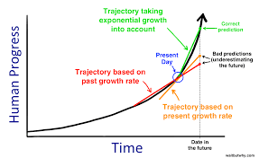
What is Artificial Intelligence?
Artificial Intelligence (AI), encompassing machine learning, deep learning, natural language processing (NLP), and computer vision, is a transformative force reshaping industries worldwide. By mimicking human cognitive functions, AI automates repetitive tasks, optimizes complex systems, and enables data-driven decision-making. In engineering, AI enhances design, manufacturing, and maintenance processes across core branches like civil, mechanical, electrical, and chemical engineering. In CSE and allied fields, AI powers innovations in software engineering, cybersecurity, and data analytics. For entrepreneurs, AI offers tools to create disruptive products and services, driving business innovation.
This report examines how AI is revolutionizing:
• Core engineering disciplines through automation and optimization. • CSE and allied fields via intelligent systems and algorithms.
• Innovation and entrepreneurship by enabling data-driven strategies and scalable solutions.

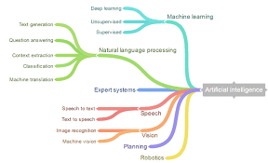

AI In Core Branches of Engineering Disciples
Civil Engineering: -
AI enhances civil engineering by optimizing design, construction, and maintenance processes.
• Structural Health Monitoring: AI-powered sensors analyse real-time data from bridges and buildings to predict maintenance needs, reducing costs and improving safety. For example, IBM’s Watson monitors infrastructure health using IoT and machine learning.
• Construction Automation: AI-driven robots, like those developed by Construction Robotics, automate tasks such as bricklaying, increasing productivity by 30– 40%.
• Urban Planning: AI models, such as those used in Singapore’s Smart Nation initiative, optimize traffic flow and energy consumption in smart cities.
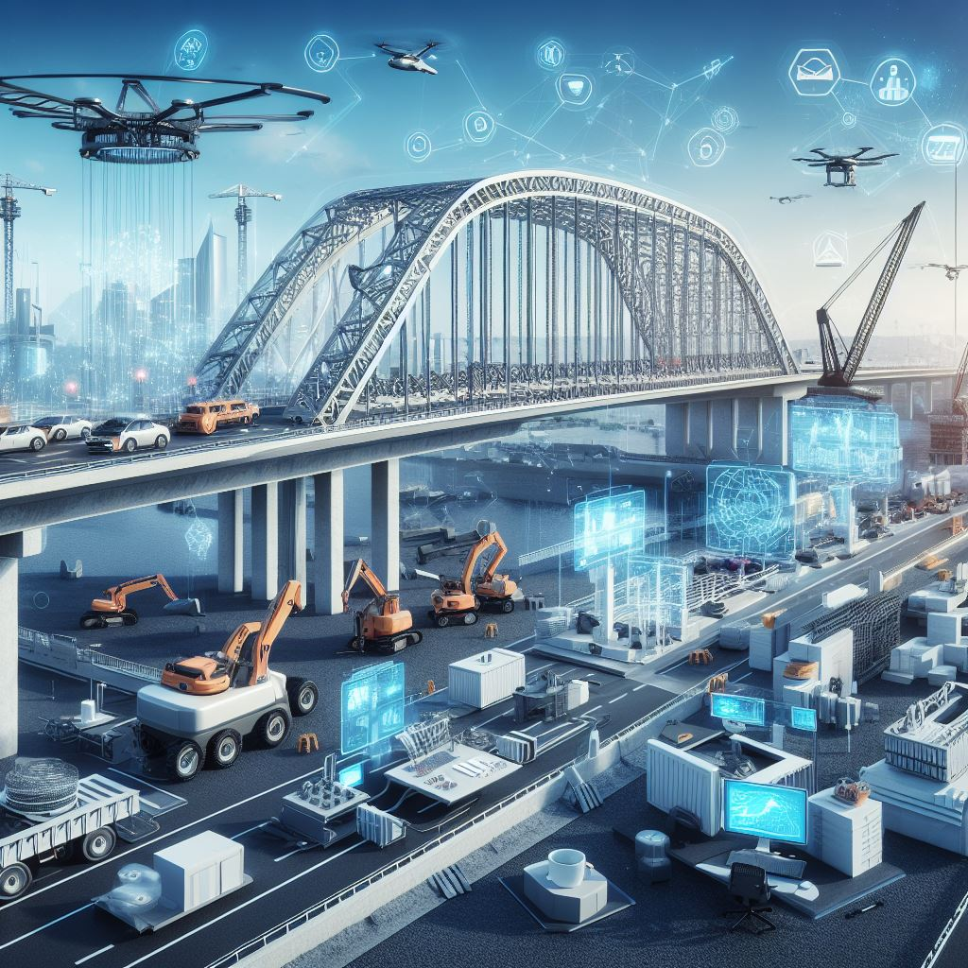

Mechanical Engineering: -
In mechanical engineering, AI streamlines design, manufacturing, and predictive maintenance.
• Generative Design: Autodesk’s AI-based generative design tools create thousands of design alternatives, optimizing for weight, strength, and material use. Boeing uses this to design lightweight aircraft components.
• Predictive Maintenance: General Electric (GE) employs AI to predict equipment failures in turbines, reducing downtime by up to 20%.
• Robotics: AI-powered collaborative robots (Cobots) enhance assembly lines, as seen in Tesla’s Gigafactories, improving precision and scalability.
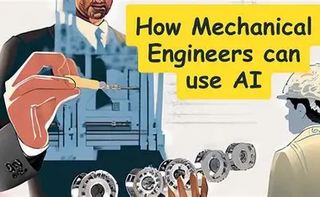

Electrical Engineering: -
AI transforms electrical engineering through smart grids, renewable energy optimization, and circuit design.
• Smart Grids: AI algorithms manage energy distribution in smart grids, balancing supply and demand. Googles DeepMind reduced data center energy consumption by 40% using AI.
• Renewable Energy: AI optimizes wind turbine placement and solar panel efficiency. Siemens uses AI to predict wind patterns, increasing energy output by 15%.
• Chip Design: NVIDIA leverages AI to automate semiconductor design, accelerating development cycles for GPUs.


Chemical Engineering: -
AI enhances chemical engineering by optimizing processes and developing new materials.
• Process Optimization: AI models predict chemical reaction outcomes, reducing trial-and-error in manufacturing. BASF uses AI to optimize production, cutting costs by 10%.
• Material Discovery: AI accelerates the discovery of sustainable materials, such as biodegradable plastics, through predictive modelling.
• Quality Control: AI-powered computer vision systems detect defects in chemical products, improving yield rates.
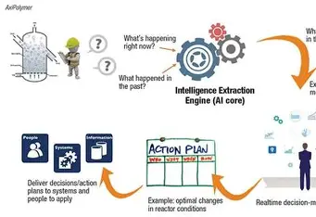

AI in Computer Science & Engineering (CSE) and Allied Fields
AI is at the heart of CSE and its allied fields, driving advancements in software development, cybersecurity, data science, and more.
Software Engineering: -
AI transforms software development by automating coding, testing, and deployment.
• Code Generation: Tools like GitHub Copilot, powered by OpenAI’s Codex, assist developers by generating code snippets, reducing development time by 30%.
• Automated Testing: AI-driven testing frameworks, such as Testim, identify bugs and optimize test cases, improving software reliability.
• DevOps Optimization: AI enhances CI/CD pipelines by predicting deployment risks, as seen in tools like CircleCI.
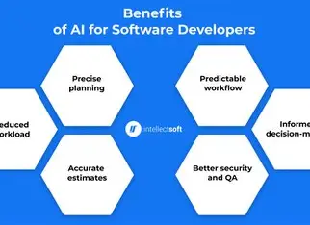
Cybersecurity: -
AI strengthens cybersecurity by detecting threats and automating responses.
• Threat Detection: AI-powered systems, like Darktrace, use anomaly detection to identify cyberattacks in real time, reducing response times by 50%.
• Phishing Prevention: NLP models analyse emails to detect phishing attempts, protecting organizations from data breaches.
• Zero Trust Architecture: AI enforces dynamic access controls, ensuring secure remote work environments.


Data Science and Analytics: -
AI enables advanced data analytics, uncovering insights from massive datasets.
• Predictive Analytics: Retail giants like Amazon use AI to forecast demand, optimizing inventory and reducing waste.
• Natural Language Processing: NLP models, such as BERT, power chatbots and sentiment analysis tools, enhancing customer engagement.
• Big Data Processing: AI frameworks like Apache Spark accelerate data processing, enabling real-time analytics.

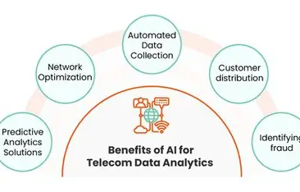
Internet of Things (IoT)
AI enhances IoT by enabling intelligent edge computing and data integration.
• Smart Devices: AI-powered IoT devices, like Nest thermostats, learn user preferences to optimize energy use.
• Industrial IoT: AI analyzes sensor data in factories, predicting equipment failures and improving uptime.
• Healthcare IoT: Wearable devices use AI to monitor patient health, enabling early intervention.

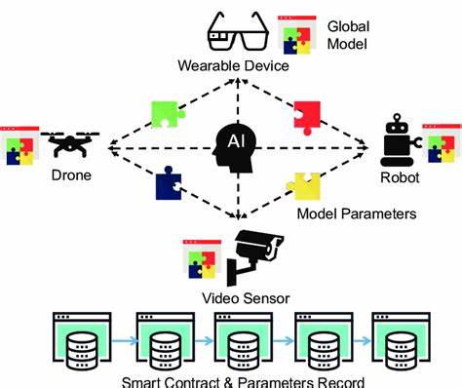

AI In Innovation
AI fosters innovation by enabling rapid prototyping, personalized solutions, and cross disciplinary applications.
Rapid Prototyping: -
AI accelerates product development through simulation and automation.
• Virtual Testing: AI simulates product performance, reducing the need for physical prototypes. For example, Formula 1 teams use AI to test aerodynamics virtually.
• 3D Printing: AI optimizes 3D printing parameters, as seen in GEs jet engine
Personalised Solutions: -
AI tailors products and services to individual needs.
• Healthcare: AI-driven diagnostics, like those from IBM Watson Health, personalize treatment plans based on patient data.
• Education: AI platforms like Coursera adapt learning content to student performance, improving outcomes.

Cross Disciplinary Applications
AI bridges disciplines, creating novel solutions.
• Biomedical Engineering: AI analyses medical imaging, improving cancer detection rates by 20%.
• Environmental Engineering: AI models predict climate patterns, aiding disaster preparedness.
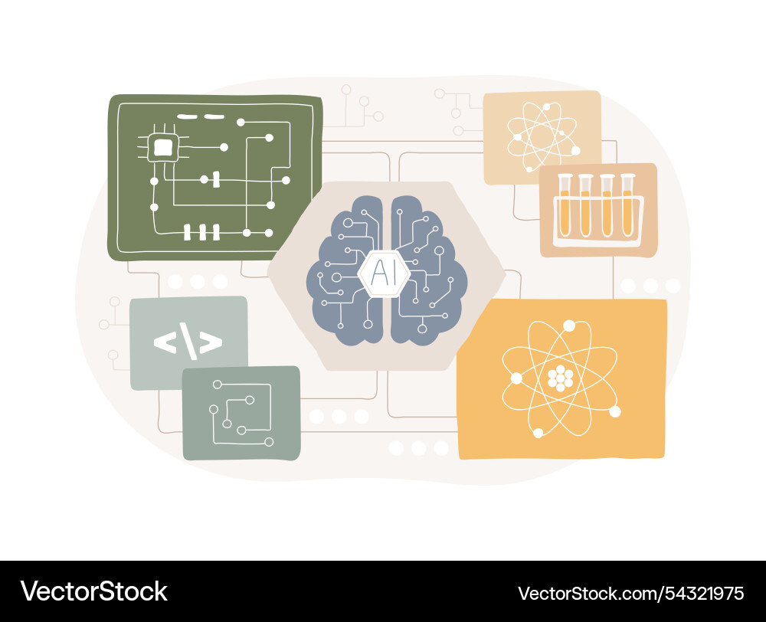

AI In Entrepreneurship

AI empowers entrepreneurs to create disruptive solutions, optimize operations, and gain competitive advantages.
Disruptive Business Models
AI enables innovative products and services.
• AI Startups: Companies like Grammarly use NLP to enhance writing, capturing millions of users.
• On-Demand Services: Uber leverages AI for route optimization and dynamic pricing, revolutionizing transportation.
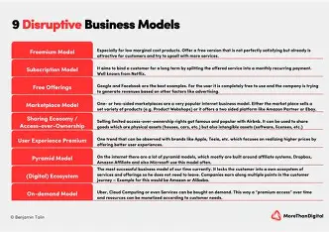
Operational Efficiency
AI streamlines business processes, reducing costs.
• Customer Support: AI chatbots, like those from Zendesk, handle 70% of customer queries, freeing human agents for complex tasks.
• Supply Chain Management: AI optimizes logistics, as seen in Walmart’s inventory management system, reducing stockouts by 15%.

Data Driven Decision-Making
AI provides actionable insights for strategic planning.
• Market Analysis: AI tools analyse consumer trends, enabling targeted marketing campaigns.
• Financial Forecasting: Fintech startups like Upstart use AI to predict loan defaults, improving lending accuracy.
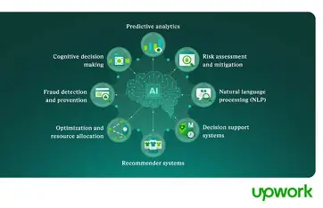
Challenges and Ethical Considerations
While AI offers immense potential, it poses challenges and ethical dilemmas.
• Data Privacy: AI systems require vast datasets, raising concerns about user consent and security.
• Bias and Fairness: AI models can perpetuate biases, as seen in facial recognition systems with higher error rates for certain demographics. • Job Displacement: Automation may lead to workforce disruptions, necessitating reskilling programs.
• Regulation: Governments must balance innovation with oversight to prevent misuse.
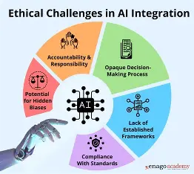

Future Prospects
AIs transformative potential will continue to grow, driven by advancements in computing power, algorithms, and data availability. • Engineering: AI will enable fully autonomous construction sites and self-healing materials.
• CSE: Quantum computing combined with AI will solve complex problems in cryptography and optimization.
• Entrepreneurship: AI will democratize innovation, enabling small startups to compete with industry giants.
• Sustainability: AI will drive solutions for climate change, optimizing energy and resource use.
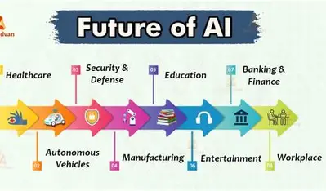

Conclusion
AI is a game-changer across engineering, CSE, innovation, and entrepreneurship. By automating tasks, optimizing processes, and enabling data-driven decisions, AI empowers engineers and entrepreneurs to create efficient, scalable, and disruptive solutions. However, addressing ethical challenges and ensuring equitable access to AI technologies are critical for sustainable progress. As AI continues to evolve, its integration into diverse domains will redefine industries and shape a smarter, more innovative future.

